Performance Analysis and ...
............ by:
Your Name
A Thesis Submitted in Fulfillment of the Requirements for the Degree of
Bachelor or Master of Science
in
The name of your major

Department of Computer Science and Technology Wenzhou-Kean University
Supervised By: Supervisor’s Name
©June 2025

Bachelor or Master of Science (2025) Wenzhou-Kean University
TITLE: | Thesis Title Line One  Optional Second Line
AUTHOR: | My Name  B.Sc., (The name of your major)  Wenzhou-Kean University  Wenzhou, China
SUPERVISORS: | Dr. Firstname Lastname  Enter the name of your second supervisor, if applicable
NUMBER OF PAGES: | Fill with the last Roman numeral page of the front matter, 16
Computer Science and Technology Wenzhou, China

Abstract
An abstract of a dissertation provides a succinct summary of the research work and its contributions. It should include a description of the research topic and objective, a brief overview of the methodology and research process, and a summary of the conclusions and contributions. The abstract must be clear and self-contained, conveying the essential ideas and main contributions without the need to read the entire dissertation.
The abstract should be concise and direct, avoiding terms like “the first chapter” or “the second chapter,” which suggest it is merely an outline. Instead, it should clearly and independently summarize the research.
Keywords are essential for indexing and should reflect the core information of the dissertation. An abstract may include up to five keywords, separated by semi-colons.
Keywords: Keyword1, Keyword2, Keyword3, Keyword4.

Acknowledgements
For example: I am deeply grateful to my supervisor, Professor ×××, and Associate Professor ×× of the Department of ×××, for their careful guidance and support. Their mentorship has been invaluable and will benefit me throughout my life.
I also extend my heartfelt thanks to Professor ××× for his enthusiastic guidance and assistance during my ×××-month collaborative research in the Department of ××× at the ×××.
My sincere thanks go to Professor ×××, the director of the ××××× Laboratory, and all the teachers and classmates in the laboratory for their unwavering help and support. Lastly, I would like to express my special thanks to the ××× for funding this project.

Contents
Abstract iii
Acknowledgements iv
List of Figures vii
List of Tables viii
Definition of Acronyms ix
Definition of Notations x
- Introduction 1
  - Overview of AAA . . . . . . . . . . . . . . . . . . . . . . . . . . . . . 2
  - Motivation . . . . . . . . . . . . . . . . . . . . . . . . . . . . . . . . . 2
  - Problem Statement . . . . . . . . . . . . . . . . . . . . . . . . . . . . 2
  - Objectives and Scope . . . . . . . . . . . . . . . . . . . . . . . . . . . 2
  - Thesis Structure . . . . . . . . . . . . . . . . . . . . . . . . . . . . . 3
  - Examples of Figures . . . . . . . . . . . . . . . . . . . . . . . . . . . 3
  - Tables with Notes . . . . . . . . . . . . . . . . . . . . . . . . . . . . . 4
    - Example for Graduate Students . . . . . . . . . . . . . . . . . 5
    - Example for Undergraduate Students . . . . . . . . . . . . . . 6
  - Summary: Dissertation/Thesis Technical Content . . . . . . . . . . . 6
    - Introduction . . . . . . . . . . . . . . . . . . . . . . . . . . . 6
    - Background and Literature Review . . . . . . . . . . . . . . . 6
    - Approach/Methodology . . . . . . . . . . . . . . . . . . . . . 7
    - Implementation/Research Findings . . . . . . . . . . . . . . . 7
    - Evaluation/Validation . . . . . . . . . . . . . . . . . . . . . . 7
    - Discussion . . . . . . . . . . . . . . . . . . . . . . . . . . . . . 7
    - Conclusion . . . . . . . . . . . . . . . . . . . . . . . . . . . . 7
    - References: Examples . . . . . . . . . . . . . . . . . . . . . . 8
- Literature Review 9
  - Introduction . . . . . . . . . . . . . . . . . . . . . . . . . . . . . . . . 10
  - Previous Work . . . . . . . . . . . . . . . . . . . . . . . . . . . . . . 10
  - Research Gaps . . . . . . . . . . . . . . . . . . . . . . . . . . . . . . 11
  - Summary . . . . . . . . . . . . . . . . . . . . . . . . . . . . . . . . . 11
- Methodology and Theory of Work 12
  - Examples of Algorithms and Equations . . . . . . . . . . . . . . . . . 12
- Implementation, Results, and Discussion 14

5 Conclusion and Future Work 15
5.1 Conclusion and Implications . . . . . . . . . . . . . . . . . . . . . . . 15
5.2 Future Work . . . . . . . . . . . . . . . . . . . . . . . . . . . . . . . 15
Bibliography 16
References 16

List of Figures
1.1 Example figure for a master’s thesis . . . . . . . . . . . . . . . . . . . 3
1.2 Example figure for a bachelor’s thesis . . . . . . . . . . . . . . . . . . 4

List of Tables
1.1 Example Table with Notes for Graduate Students . . . . . . . . . . . 5
1.2 Example Table with Notes for Undergraduate Students . . . . . . . . 6

Definition of Acronyms
Acronym | Definition
CPU | Central Processing Unit
GPU | Graphics Processing Unit
RAM | Random Access Memory
ROM | Read-Only Memory
API | Application Programming Interface

Definition of Notations
Symbol | Meaning
n | Number of elements
x | A variable or data point
µ | Mean (average)
σ | Standard deviation
P | Summation

Chapter 1

Introduction
The introduction is the very first part of any manuscript. It provides context for your research, introduces your research question, and outlines your work’s structure. In many ways, the introduction mirrors your Exposé. It is designed to give the reader an idea of what to expect in your thesis and helps set the scene for the rest of the text. An introduction in a dissertation generally includes the following parts:
Statement of the Problem: Clearly articulate what the research problem is. Note: Ensure the topic addresses a real issue rather than a non-problematic one.
Background and Significance: Explain why this topic was chosen for research, detailing its contributions to the field and its theoretical and practical significance to society.
A Brief Literature Review: Provide a comprehensive review and critique of the literature within the scope of the research topic. Highlight the current state of research, unresolved issues, and the exploratory aspects of your study.
Research Methodology: Describe the academic research methods used in the dissertation.
Structure of the Dissertation: Outline the organizational structure of the dissertation.
The introduction chapter should provide a comprehensive overview of the project.
It could include the following sections:

1.1 Overview of AAA
Provide background information on the topic of your project. Explain the context and the importance of the problem you are addressing.

1.2 Motivation
The Motivation section explains why you chose your research topic, highlighting its significance and relevance. Key Components: “Briefly describe the broader field of your research”; “Mention relevant trends or developments in computer science engineering”; “Share why you chose this topic and mention any relevant experiences”; “Discuss the potential impact of your research. Highlight practical applications or theoretical contributions”; “Identify gaps in current research that your work will address”.

1.3 Problem Statement
Clearly state the problem your project aims to solve. Discuss why this problem is significant and worth solving.

1.4 Objectives and Scope
List the objectives of your project. What do you aim to achieve with this project?
Define the scope of your project. What are the boundaries and limitations? What is included and what is not?
1.5 Thesis Structure
Outline the structure of your thesis. Briefly describe what each chapter will cover.

1.6 Examples of Figures
Figures are typically included using the environment and the command, as shown in the source code for Figure 1.1 or Figure 1.2. It is recommended to use PDF format for vector images, such as data visualizations; JPG format for photographs; and PNG format for other raster images. Note that LaTeX does not support TIFF format, and EPS format is considered outdated.
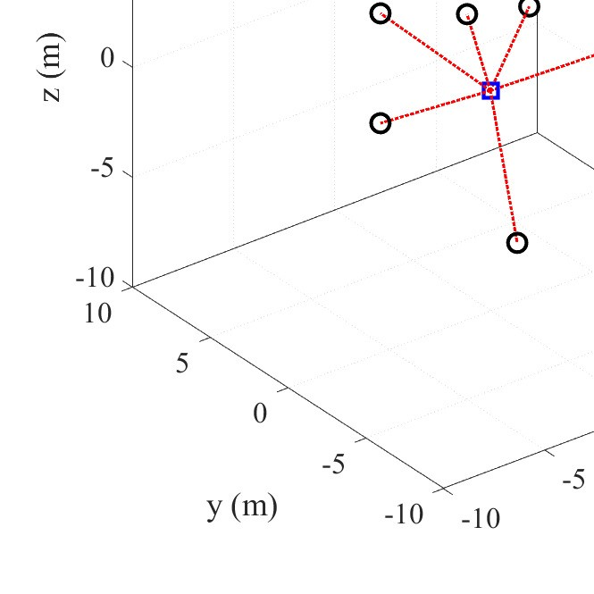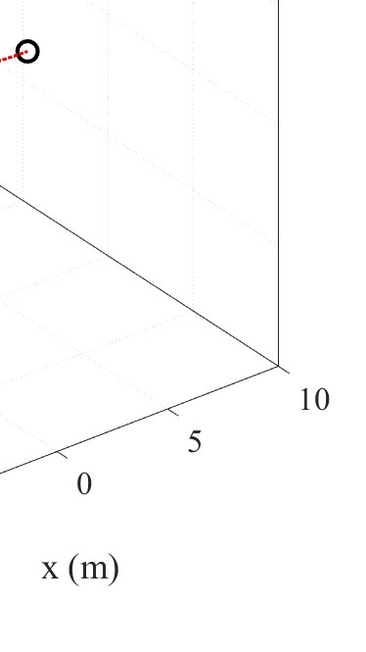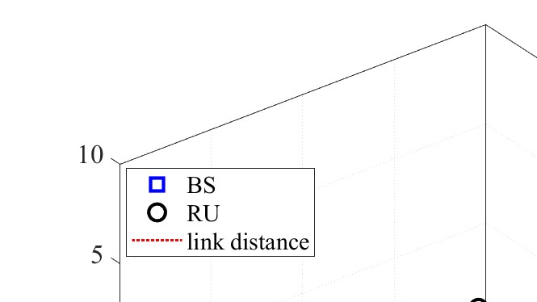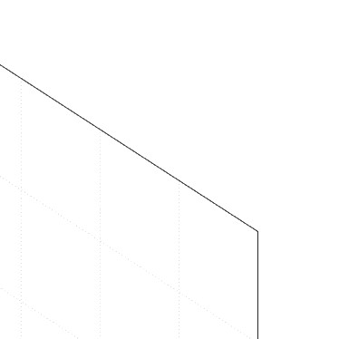
Figure 1.1: Example figure for a master’s thesis
When a figure consists of two or more subfigures, each subfigure should be labeled with (a), (b), (c), etc., and should have a subcaption.
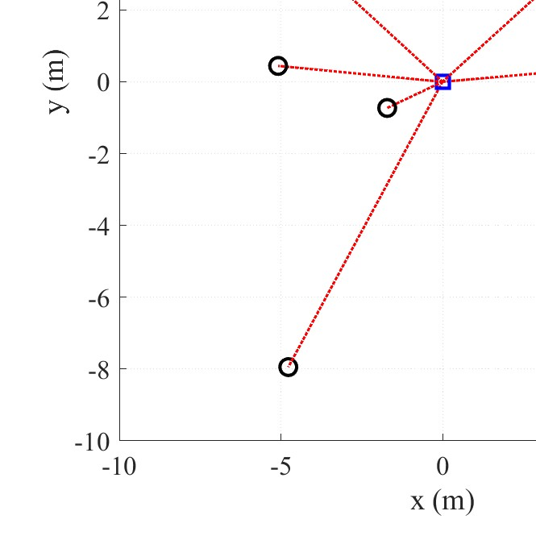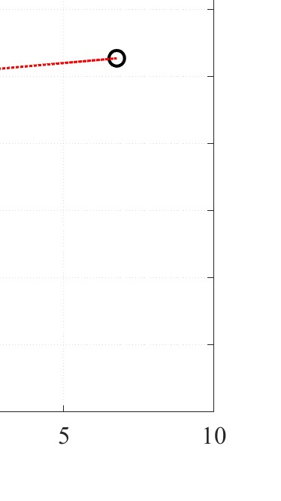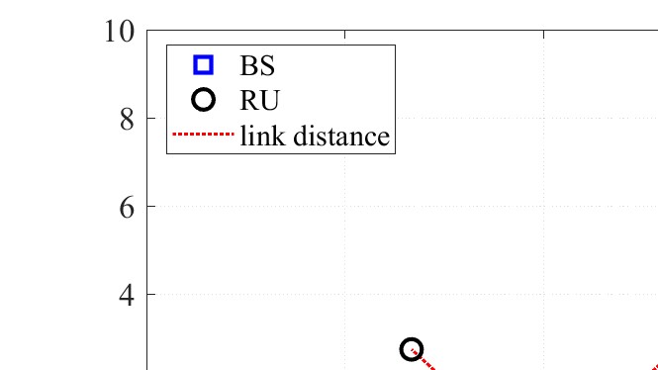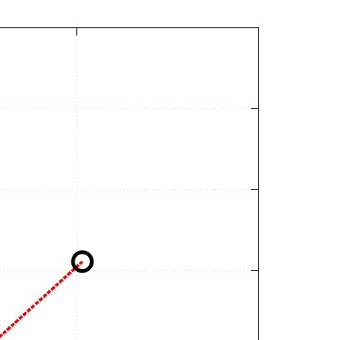
Figure 1.2: Example figure for a bachelor’s thesis

1.7 Tables with Notes
If a table contains notes, especially when annotations within the table are required, the three part table package can be used. Graduate students should use lowercase letters (a, b, c, etc.) for note numbering, while undergraduates should use circled numbers (¬, ­, ®, etc.).
Table captions should be placed above the table, while figure captions should be positioned below the figure. Avoid using boldface type or colored fonts for table and figure captions.

1.7.1 Example for Graduate Students
Table 1.1: Example Table with Notes for Graduate Students
File Name | Description
AAAAª | Example Table with Notes for Graduate Students
CCCCC^{b} | Example Table with Notes for Graduate Students
EEEEE | Example Table with Notes for Graduate Students
ª Example Table with Notes for Graduate Students. ^{b} Example Table with Notes for Graduate Students.

1.7.2 Example for Undergraduate Students
Table 1.2: Example Table with Notes for Undergraduate Students
File Name | Description
AAAAA¬ | Example Table with Notes for Undergraduate Students
BBBBB­ | Example Table with Notes for Undergraduate Students
CCCCC | Example Table with Notes for Undergraduate Students
¬ Example Table with Notes for Undergraduate Students.
­ Example Table with Notes for Undergraduate Students.

1.8 Summary: Dissertation/Thesis Technical Content
The components of a dissertation or thesis may vary by discipline, but generally include the following elements:

1.8.1 Introduction
This section summarizes the research problem addressed in the thesis or dissertation. It should clearly define the problem(s) and state the rationale and objectives of the research. The introduction should also provide context, outlining what the reader can expect in the rest of the document, and breaking down the proposed solutions into parts that will be explained in subsequent chapters.

1.8.2 Background and Literature Review
This section offers a comprehensive review of relevant literature, identifying weaknesses and deficiencies in existing work related to the research problem. It should explain how others have addressed similar issues and which approaches were used.

1.8.3 Approach/Methodology
This section describes the research methods and techniques used in the study. It should detail which methodologies were chosen, why they were selected over others, and how they were applied in the research.

1.8.4 Implementation/Research Findings
This part, which may span multiple chapters, presents the research findings with adequate data. It should describe how the approach was implemented, including algorithms, architectures, and process diagrams.

1.8.5 Evaluation/Validation
This section explains how the research findings were evaluated, tested, and validated. It should include the data from verification, testing, or experiments, along with sufficient explanations.

1.8.6 Discussion
This part provides a scholarly discussion of the findings and suggests future research directions. It should also detail why the findings of the thesis or dissertation are superior to previous or existing results by others.

1.8.7 Conclusion
The conclusion should restate the main theme and findings of the thesis or dissertation, and bring the entire document together.

1.8.8 References: Examples
For references in your document, you can cite a book using¹, a journal article with², or a conference paper with³. If you’re using information from a website, you can cite it with⁴. For academic work such as a thesis or dissertation, use⁵, and for a technical report, you can reference it using⁶. To cite a patent, use⁷. Finally, for a specific chapter in an edited book, you can use⁸.

Chapter 2

Literature Review
The literature review is an essential part of your research and thesis manuscript. By this stage, you should have conducted some preliminary research, for example, using Google Scholar, and reviewed existing literature in the field. Now, it is time to delve deeper and gain a thorough understanding of the state-of-the-art in your research area. Follow the citation trail by reading the papers cited by the ones you have read until you loop back to your starting point. Over time, you will notice that reading one paper will lead to fewer additional papers. Ultimately, you will have read around 100-120 papers, although not all will need to be discussed or cited in your thesis. Be judicious with your time and avoid spending too much on obscure papers. For older papers, the citation count can be a good indicator of their impact. Additionally, retain some papers for the related work section, which discusses alternative approaches to your solution. The literature review provides the necessary foundation for understanding the rest of your thesis.
In a research paper, the literature review typically serves two main purposes: First, it introduces the terminology and definitions you will use throughout your

CHAPTER 2. LITERATURE REVIEW

thesis. For instance, there may be varying definitions of a Linux kernel¹—whether it is the core component of an operating system or a popcorn seed. This is your chance to clarify terms, ideally with citations. Second, the literature review allows you to present the concepts that will be utilized in your thesis. Every non-trivial piece of information should be included here. It can be challenging to determine what is considered trivial versus non-trivial. Think about your audience (e.g., your advisor) and avoid overloading your thesis with excessive details that might make it tedious. Generally, anything you learned in compulsory lectures can be considered common knowledge in your field, while new information to most recent graduates is non-trivial.
The literature review in a thesis also serves an additional purpose: It demonstrates that you, as a student, have a comprehensive understanding of the research area. Conversely, if you or your advisor find any gaps while writing this section, it indicates a need for further research to address those gaps.
2.1 Introduction

Provide an overview of what will be covered in the literature review.

2.2 Previous Work

Discuss the existing research that is relevant to your project (“The current status and analysis of research in this direction at home and abroad” and “The results of the previous theoretical research and experimental demonstration work” ). Include significant findings from key papers.
¹e.g., in this question: Why is the gcc compiler so slow when I compile the Linux kernel?

CHAPTER 2. LITERATURE REVIEW

2.3 Research Gaps
Identify the gaps in the existing research that your project aims to address.

2.4 Summary
Summarize the main points of the literature review and how they relate to your project.
Chapter 3

Methodology and Theory of Work

3.1 Examples of Algorithms and Equations
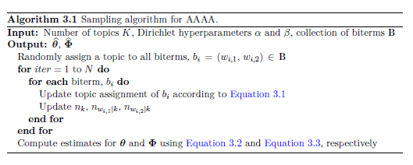
(3.1)
(3.2)
CHAPTER 3. METHODOLOGY AND THEORY OF WORK

(3.3)

Chapter 4
Implementation, Results, and Discussion
Chapter 5

Conclusion and Future Work

5.1 Conclusion and Implications
Summarize the main findings and achievements of your project.
Discuss the implications of your work and its potential impact on the field.
5.2 Future Work
Suggest areas for future research or improvements based on your findings.

Bibliography
- J. Smith, Introduction to Wireless Networks, 2nd ed. Berlin: Springer, 2020.
- J. Doe and S. Brown, “Advances in 5G networks,” Journal of Wireless Communications, vol. 15, no. 3, pp. 123-145, 2019.
- P. Green, “AI in wireless communication systems,” in Proceedings of the 2021 IEEE International Conference on Communications, Paris, France, 2021, pp. 234-240.
- “5G technology overview,” 5G Insights, accessed Sep. 12, 2024. [Online]. Available: https://www.5ginsights.com/overview
- A. Johnson, “A study on 6G network optimization,” M.S. thesis, Dept. of Electrical Engineering, Stanford Univ., Stanford, CA, 2022.
- B. Patel, “Next-generation communication systems,” Technical Report TR-202005, Dept. of Computer Science, MIT, Cambridge, MA, 2020.
- M. Brown, “Method for optimizing wireless network performance,” U.S. Patent 8,765,432, issued Feb. 10, 2021.
- R. Clark, “AI applications in IoT,” in AI and Future Networks, 2nd ed., P. Singh, Ed. New York: Wiley, 2021, ch. 5, pp. 120-145.

